
WHAT IS GAME
DEVELOPMENT?

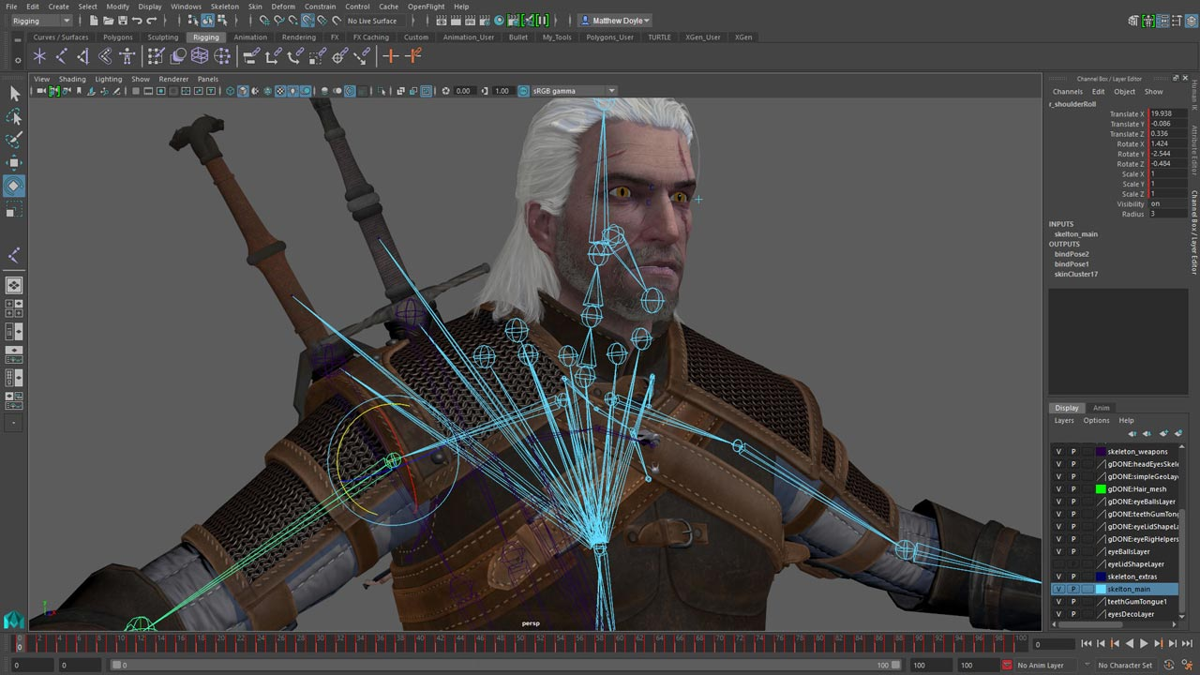
Video game development is the process of creating a video game. The effort is undertaken by a game developer, which may range from a single person to an international team dispersed across the globe. Traditional commercial PC and console games are normally funded by a publisher, and can take several years to reach completion. Indie games can take less time and can be produced at a lower cost by individuals and smaller developers. The independent game industry has seen a substantial rise in recent years with the growth of new online distribution systems, such as Steam and Uplay, as well as the mobile game market, such as for Android and iOS devices.
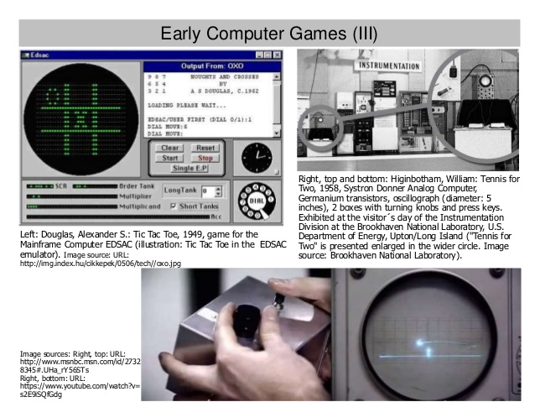
The first video games were noncommercial, and were developed in the 1960s. They required mainframe computers to run and were not available to the general public for play. Commercial game development began in the 1970s with the advent of first-generation video game consoles and early home computers like the Apple I. Due to low costs and low capabilities of computers, a lone programmer could develop a full game. However, approaching the 21st century, ever-increasing computer processing power and heightened consumer expectations made it difficult for a single person to produce a mainstream console or PC game. The average cost of producing a triple-A video game slowly rose from US$1–4 million in 2000 to over $5 million in 2006, then to over $20 million by 2010.

Mainstream PC and console games are generally developed in phases. First, in pre-production, pitches, prototypes, and game design
documents are written. If the idea is approved and the developer receives funding, a full-scale development begins. This usually involves a team of 20–100 individuals with various responsibilities, including designers, artists, programmers, and testers.


Should I Be a Gaming Programmer?

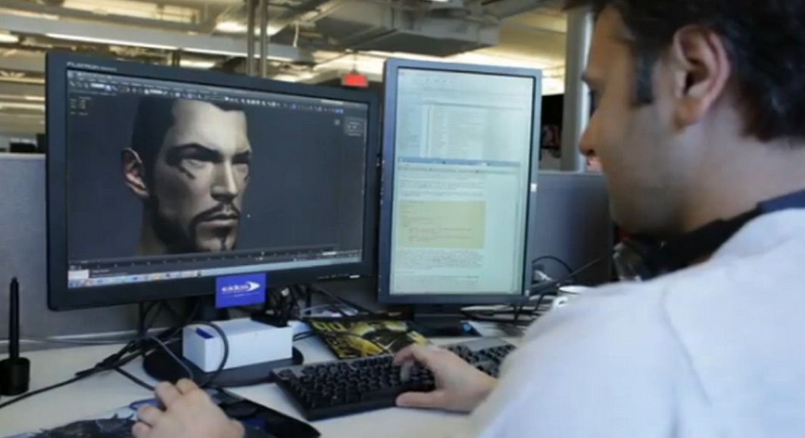
Gaming programmers help write and code the software for video games. In your job, you'll typically be part of a collaborative creative team that includes game designers and artists. Your work will primarily be in the area of coding, which tells the computer or system what to do for the game to be played.
As a gaming programmer, you might design core game features, oversee game testing and conduct design reviews. You could also work in production, artistic concept, and game play. This career allows for great creativity, but the competition for jobs is intense.
Steps to be a Gaming Programer

Step 1: Develop High Level Math skills - Because coding is by definition the creation of a mathematical equation that directs the computer to perform in certain ways, game programmers need high level math skills in order to be successful.
Step 2: Get a Bachelor's Degree
Gaming programmers may have a general background in computer science or they may have completed a formal education program to become a video game designer.
Step 3: Build a Portfolio
The most effective way to get noticed by gaming studios is to create games and put them in a portfolio. According to senior technical staff from Blitz Games Studios, a successful portfolio should include several small games that can be played to completion.
Step 4: Find an Entry Level Position as a Game Programmer
Entry level programmers often have difficulty breaking into the video game industry because most major studios require experience. Some new programmers find their first professional positions at smaller studios, making short, simple games for mobile devices and social media sites.

Step 5: Advance to Become a Software Developer
With enough experience, programmers may become software developers. While some duties between these two positions overlap, developers typically spend more time designing and conceptualizing games, rather than coding them.

Gaming programmers face stiff competition in the job market, so they must prepare themselves with high-level math courses, programming courses, bachelor's degrees, portfolios, and internships hoping to land entry-level positions that will lead them to higher positions in the programming world.

Best Game Programming Books To Be Awesome Video Game Developer

Game Engine Architecture
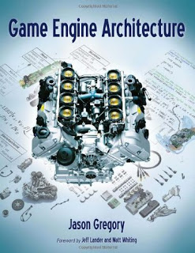
The book on Game Engine Architecture which covers each and every system of the modern game engines along with the detailing of inter-system interactions.

Mathematics For 3D Game Programming And Computer Graphics
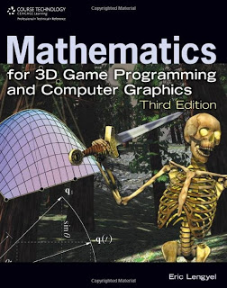
The book on 3D mathematics which will act as an excellent reference for those who are working on computer graphics and 3D programming.

Game Coding Complete
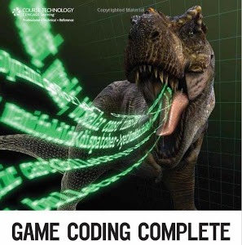
A comprehensive book on game coding which acts as a journeyman’s book for game programmers by complementing the knowledge gained through introductory texts and broadening the horizon of knowledge by introducing more advanced topics.

Artificial Intelligence For Games
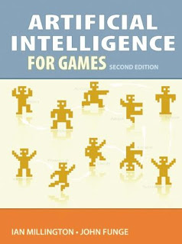
The book on Gaming artificial intelligence provides you with a refreshing account of the artificial intelligence knowledge in the area of game development. The book contains all the information that is necessary for a reader to create an implementation on his own.
Domingo, John Carlo R.
ICS1 MWF 1:45PM-3:00PM M307
Sources:

https://damassets.autodesk.net/content/dam/autodesk/www/industries/media-entertainment/game-development/images/game-design-development-benefits-blazing-fast-performance-1280x720-nc.jpg

http://www.kinyu-z.net/data/wallpapers/208/1431792.jpghttps://image.slidesharecdn.com/gcaxcomputergames-140624172648-phpapp01/95/history-of-computer-art-x-computer-and-video-games-4-638.jpg?cb=1403631535

https://study.com/articles/Become_a_Gaming_Programmer_Step-by-Step_Career_Guide.html

http://www.fromdev.com/2013/07/game-development-books.html

